**SUMMER INTERNSHIP REPORT**

ON

“**PYTHON LEARNING**”

A REPORT SUBMITTED IN PARTIAL FULFILLMENT OF

THE REQUIREMENTS FOR THE AWARD OF DEGREE OF

# BACHELOR OF ENGINEERING

# IN

# ELECTRONICS & COMMUNICATION ENGINEERING

# BY

# BATTA ADITYA YADAV (1608-18-735-040)

Under the Supervision of

# Mr. Koteshwar S

# Assistant Professor

**Department of Electronics and Communication Engineering**

**(NBA Accredited)**

**MATRUSRI ENGINEERING COLLEGE**

**(Sponsored by Matrusri Education Society, Estd1980)**

**(Approved by AICTE, Affiliated to Osmania University)**

**#16-1-486, Saidabad, Hyderabad, Telangana-500 059**

[**www.matrusri.edu.in**](http://www.matrusri.edu.in)

**2020-2021**



**DEPARTMENT OF ELECTRONICS AND COMMUNICATION**

**ENGINEERING**

**Date: 03-02-2021**​

# Certificate

This is to certify that the “SUMMER INTERNSHIP REPORT” submitted by Mr.Batta Aditya Yadav Roll No. 1608-18-735-048 is work done by her and submitted during 2020-21 Academic year, in partial fulfilment of the requirements for the award of the degree of Bachelor of Engineering in Electronics and Communication Engineering of the Osmania University, Hyderabad.

Internship Coordinator Head of the Department

Mr.M.Naresh Mr.N.Srinivasa Rao

# INTERNSHIP CERTIFICATE

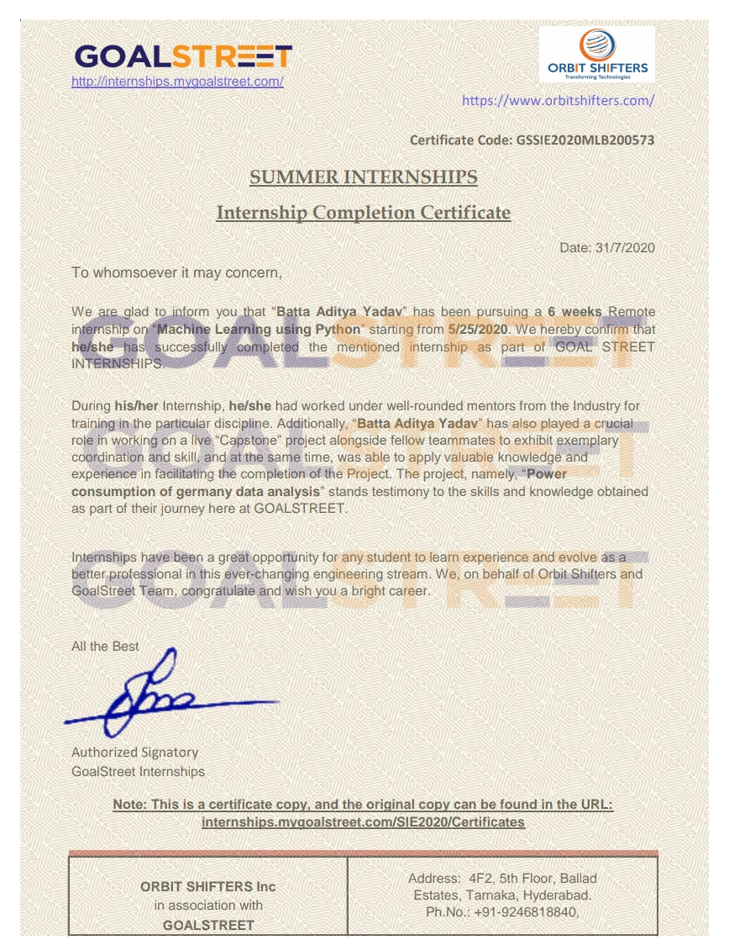

**ACKNOWLEDGEMENT**

I am highly indebted to the management of GOAL STREET who had immensely supported and motivated to learn something new during hither and thither situation of pandemic and lockdown.

I thank my mentors Manyu and Manish Sir for their assistance at every point of learning in GOAL STREET.

I would like to use this opportunity to express my deepest gratitude to Mr.K.Durga

Naveen**,** Director of GoalStreet, who heartily welcomed me and encouraged me for this internship and helping me to make it a grand success.

I had ecstasy and excitement while learning and was indebted to mentors who carefully and cautiously clarified all our doubts without any hesitancy.

It wouldn’t be an exaggeration or personification to mention my friends and teammates had played a vital role in completion of project

Successfully.

My humble regards and thankfulness to our Principal Dr.Hanumanth Rao and Head Of Department of ECE, Dr.Nookala Srinivas Rao for encouraging us to do interns and become an useful asset in “Atma Nirbar Bharat” movement .

BATTA ADITYA YADAV

(1608-18-735-040)

**ABSTRACT**

Technology has been advanced at each and every point of our lives and lifestyle. Ever since the evolution of programming has developed to new heights, the picture of World has been changed. Python is a simple high level language which is widely used in all the social media apps and sites alongside java script. Python is user-friendly and supports different kind of libraries. A focus on code reliability makes the language easy to learn, and the expressive syntax leads to short, clear problems. Additionally, python has excellent support for interfacing with legacy code written in C, C++ and FORTRAN making it an excellent tool for integrating existing software. Creating opportunities for more integration of the physical world into computer-based systems, and result in improved accuracy, efficiency and economic benefit. Python gave new problem solving and innovative coding that is usually beneficial for technological world.

Keywords: Python , java script.

**INDEX**

Page No.

College Certificate

Internship Certificate

Acknowledgement

Abstract

1. Organisation Profile

2. Internship Objectives

3. Introduction

3.1. Python History

3.2. Python IDLE

3.3. Python Applications

4. Internship Discussion

4.1. Python Basics

4.1.1. Data Types

4.1.2. File Handling

4.1.3. Specail Functions

4.1.4. Features of Python

4.2. Object Oriented Programming

4.3. GUI programming

4.4. Python Libraries

4.4.1. Numpy

4.4.2. Pandas

4.4.3. Matplotlib

4.4.4. SQlite

4.5. Anaconda

4.5.1. Anaconda Navigator

4.5.2. Jupyter Notebook

4.5.3. Seaborn

5. Case Study on Power Consumption Of Germany

5.1. Objectives

5.2. Project information

6. Case study in Jupyter Notebook- Results and Observations

7. Project Certificate

8. Skills Acquired

8.1. Technical Skills

8.2. Professional Skills

9. Challenges Experienced

10. Conclusion

11. Bibliography

**1​.ORGANISATIONAL PROFILE**

One of my difficult challenges was the quest of reputed institutions that can deliver professional training and certificate. It took several days and enquiry to learn about organisation and finally with help of my friends and on their request I joined GOAL STREET. This organisation has a good profile regarding their mentors, trainers and staff. All kind of learning platforms like IOT, Python, AI , ML were available. Weekly reviews and feedback was taken. Our intuition has bridged the gap between academia and industry. Goal Street says “We bridge thee existing industry- academia skill gap to bolster aspirant’s employability, launching them from novices to potential recruits. It was one of the most emerging novel platforms for students to learn and recruiting of new employees that made most of us to look towards this organisation.

**2. INTERNSHIP OBJECTIVES**

* Internship helps to develop overall personality of a student and enhances confidence in field of learning.
* To learn python, web development and basic programming languages.
* To learn more certified courses.
* As to have experience in industry related problems and become a proficient graduate.
* To explore horizon of knowledge in technical skills.
* Improving communication skills.
* To learn about embedded and software interlinking.
* To develop programming languages.
* A better exposure to outside environment.
* To improve proficiency in given field.
* To maintain a positive formal and technical life further.

**3. INTRODUCTION**

* Online intern in Zoom App was continued for 2 hours daily. Web development is a first priority training learnt at first week in goal street. It ranges from basic web pages to social network sites.
* HTML is Hyper Text Markup Language to create own web pages.
* CSS is Cascading Style Sheets used as selector and declaration.
* Bootstrap is populous used for mobile- first websites.
* JavaScript is programming language for web and manipulate data.
* Python is an interpreted, high-level and general-purpose programming language. Python's design philosophy emphasizes code readability with its notable use of significant whitespace. Its language constructs and object-oriented approach aim to help programmers write clear, logical code for small and large-scale projects.

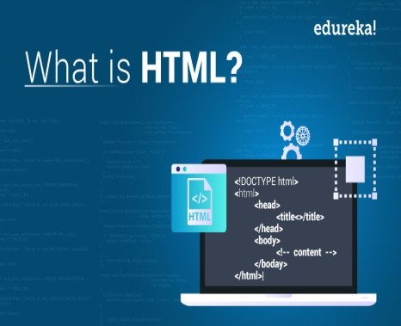 

FIG 3.1 FIG 3.2

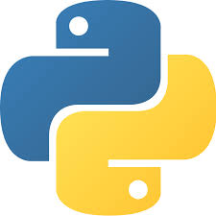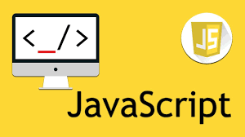

FIG 3.3 FIG 3.4

FIG 3.3 FIG 3.4

**3.1 PYTHON HISTORY**

Python was conceived in the late 1980s[36] by Guido van Rossum at Centrum Wiskunde & Informatica (CWI) in the Netherlands as a successor to ABC programming language, which was inspired by SETL capable of exception handling and interfacing with the Amoeba operating system.

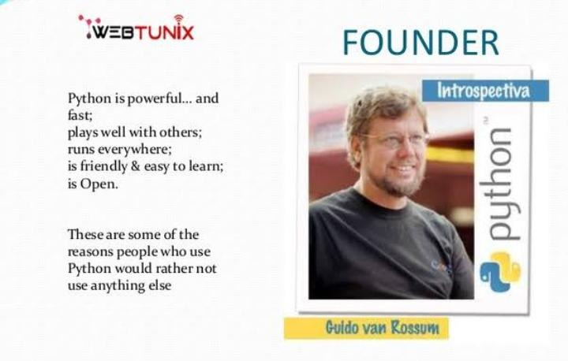

FIG 3.5 FOUNDER OF PYTHON

**3.2 PYTHON IDLE**

Every Python installation comes with an Integrated Development and Learning Environment, which you’ll see shortened to IDLE or even IDE. These are a class of applications that help you write code more efficiently. While there are many IDEs for you to choose from, Python IDLE is very bare-bones, which makes it the perfect tool for a beginning programmer. Python IDLE also provides several useful features that you’ll see in professional IDEs, like basic syntax highlighting, code completion, and auto-indentation. Professional IDEs are more robust pieces of software and they have a steep learning curve. If you’re just beginning your Python programming journey, then Python IDLE is a great alternative!

**3.3 PYTHON APPLICATIONS**

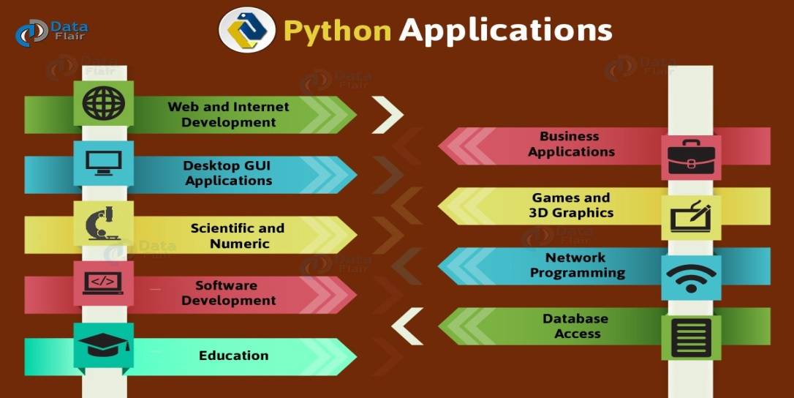

FIG 3.6

* Artificial Intelligence and Machine Learning
* Software Development
* Enterprise-level/Business Applications
* Web and Game Development

**4. INTERNSHIP DISCUSSION**

**4.1 PYTHON BASICS**

**4.1.1 DATA TYPES**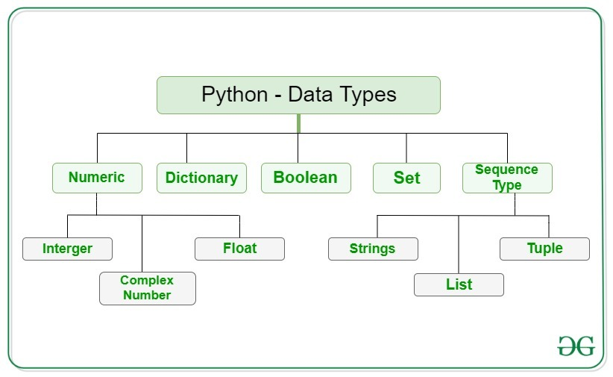

FIG 4.1

**LISTS**

Lists in Python are used to store collection of heterogeneous items. These are mutable, which means that you can change their content without changing their identity.

X6=[4, 5,6]

Type(x6)

list

**TUPPLES**

Tuples are another standard sequence data type. The difference between tuples and list is that tuples are immutable, which means once defined you cannot delete, add or edit any values inside it.

x_tuple = (2,2, 3,4,5)

y_tuple = ('c','a','k','e')

x_tuple [0]

2

**DICTIONARY**

Dictionaries are exactly what you need if you want to implement something similar to a telephone book. None of the data structures that you have seen before are suitable for a telephone book.

x_dict = {'abc':1, 'def’:2, 'nop':3, 'fgl':4}

del x_dict['fgl']

x_dict

{'abc': 1, 'def': 2, 'nop': 3}

**SETS**

Sets are a collection of distinct (unique) objects. These are useful to create lists that only hold unique values in the dataset

x_set = set('CAKE&COKE')

y_set = set('COOKIE')

print(x_set)

{'A', '&', 'O', 'E', 'C', 'K'}

**4.1.2 FILE HANDLING**

Python too supports file handling and allows users to handle files i.e., to read and write files, along with many other file handling options, to operate on files.

>>> f = open("test.txt") # open file in current directory

>>> f = open("C:/Python38/README.txt") # specifying full path

When we are done with performing operations on the file, we need to properly close the file. Closing a file will free up the resources that were tied with the file. It is done using the CLOSE ( ) method available in Python.

|  |  |
| --- | --- |
| **Method** | **Description** |
| [close()](https://www.w3schools.com/python/ref_file_close.asp) | Closes the file |
| [read()](https://www.w3schools.com/python/ref_file_read.asp) | Returns the file content |
| [write()](https://www.w3schools.com/python/ref_file_write.asp) | Writes the specified string to the file |

**4.1.3 SPECIAL FUNCTIONS**

**LAMDA FUNCTIONS**

A lambda function is a small anonymous function which can take any number of arguments, but can only have one expression.

Syntax

Lambda arguments : expression

**MAP FUNCTION**

The map () function executes a specified function for each item in an iterable. The item is sent to the function as a parameter.

Syntax

map (function, iterables)

**REDUCE FUNCTION**

The reduce (fun, seq) function is used to apply a particular function passed in its argument to all of the list elements mentioned in the sequence passed along. This function is defined in “functools” module.

**FILTER () IN PYTHON**

The filter() method filters the given sequence with the help of a function that tests each element in the sequence to be true or not.

syntax:

filter(function, sequence)

**4.1.4 FEATURES OF PYTHON**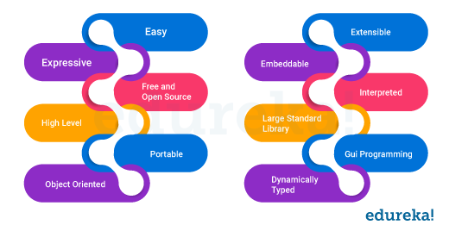

FIG 4.1

* Easy to code: Python is a high-level programming language
* Free and Open Source
* Object-Oriented Language
* GUI Programming Support
* High-Level Language

**4.2 OBJECT ORIENTED PROGRAMMING**

**Object-oriented programming** (OOP) is a method of structuring a program by bundling related properties and behaviours’ into individual **objects**. Conceptually, objects are like the components of a system. Think of a program as a factory assembly line of sorts. At each step of the assembly line a system component processes some material, ultimately transforming raw material into a finished product. An object contains data, like the raw or pre-processed materials at each step on an assembly line, and behaviour, like the action each assembly line component performs.

* class Dog:
* def __init__(self, name, age):
* self.name = name
* self.age = age

**4.3 GUI PROGRMMING**

Python has a huge number of GUI frameworks (or toolkits) available for it, from TkInter (traditionally bundled with Python, using Tk) to a number of other cross-platform solutions, as well as bindings to platform-specific (also known as "native") technologies. PyQt’s layout managers provide some cool features that make your life a lot easier when it comes to creating good-looking GUI applications. Handling the size and position of widgets without the need for any calculation

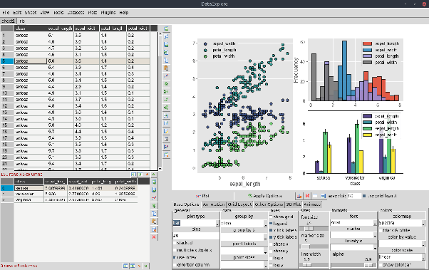

FIG 4.3

**4.4 PYTHON LIBRARIES**

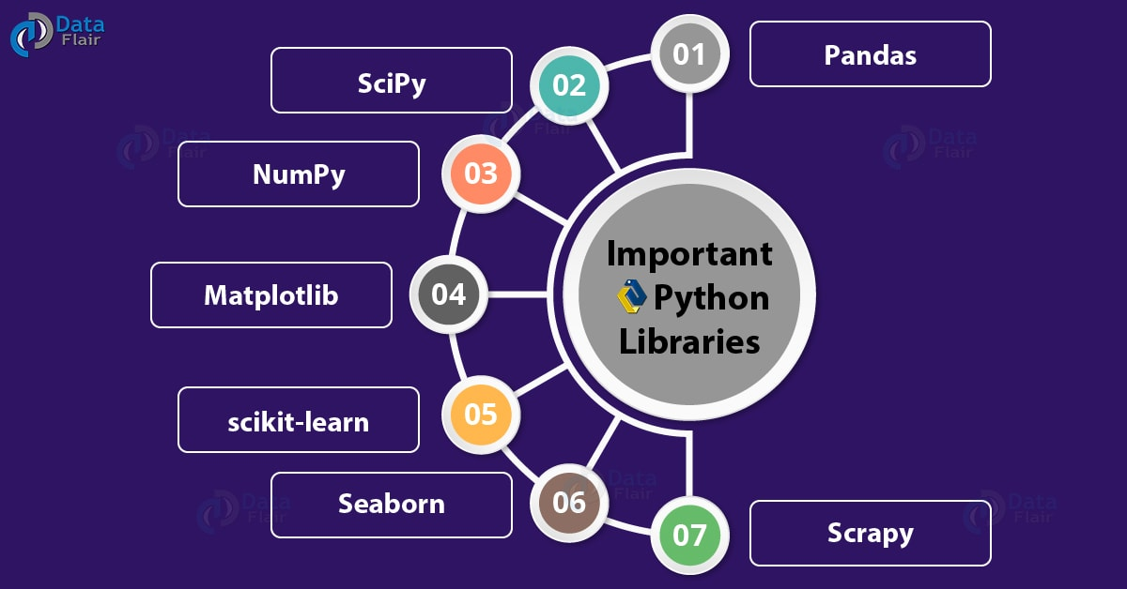

FIG 4.4.2

**4.4.1 NUMPY**

NumPy is a Python library that provides a simple yet powerful data structure: the n-dimensional array. NumPy is a Python library that provides a simple yet powerful data structure: the n-dimensional array.

Import numpy  
  
arr = numpy.array ([1, 2, 3, 4, 5])  
  
print(arr)

* [1,2,3,4,5]

**4.4.2 PANDAS**

Pandas is a Python library used for working with data sets. Pandas are also able to delete a row that are not relevant, or contains wrong values, like empty or NULL values. This is called cleanin*g* the data. The name is derived from the term "panel data", an econometrics term for data sets that include observations over multiple time periods for the same individuals. Its name is a play on the phrase "Python data analysis" itself.

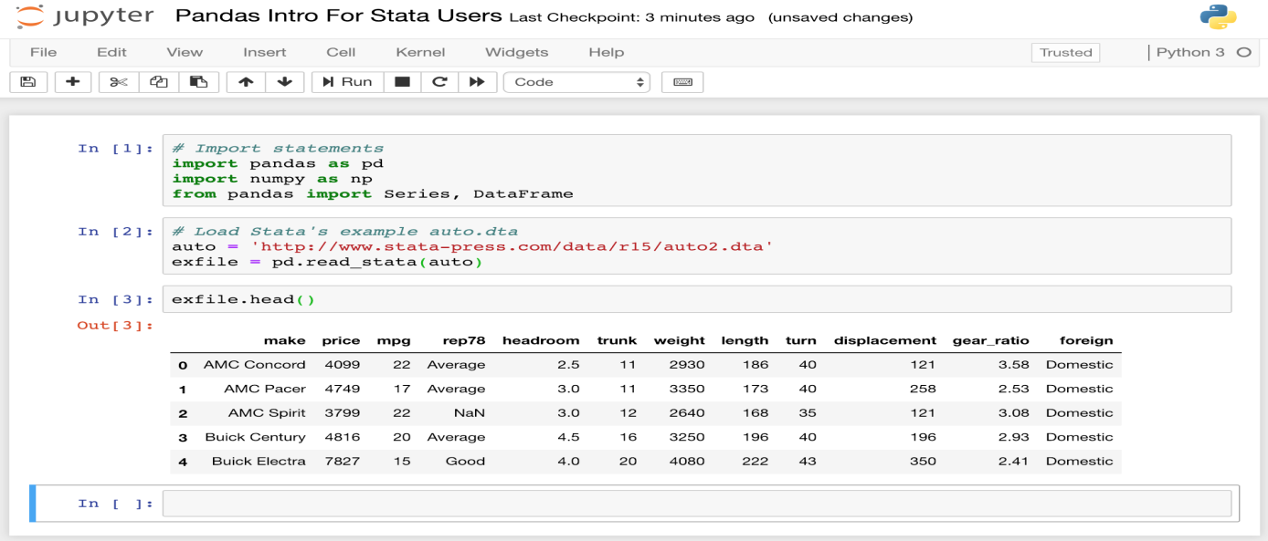

FIG 4.4.3

**4.4.3 MATPLOTLIB**

Matplotlib is one of the most popular Python packages used for data visualization. It is a cross-platform library for making 2D plots from data in arrays. Matplotlib is written in Python and makes use of NumPy, the numerical mathematics extension of Python. It can be used in Python and IPython shells, Jupyter notebook and web application servers also. One of the greatest benefits of visualization is that it allows us visual access to huge amounts of data in easily digestible visualization, histogram e.tc.

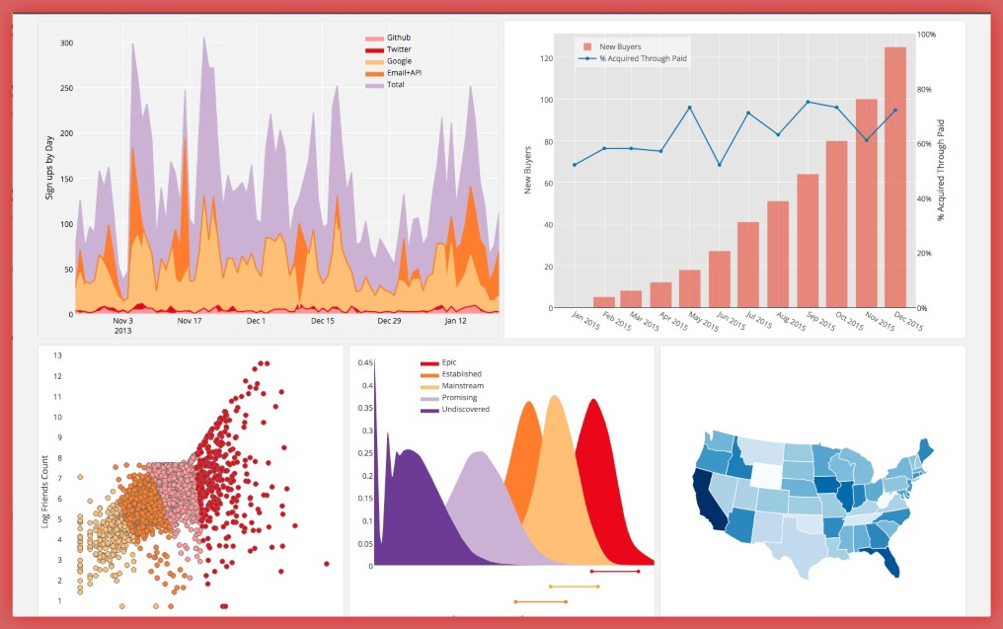

FIG 4.4.4

**4.4.4 SQLite**

SQLite is an in-process library that implements a self-contained, serverless, zero-configuration, transactional SQL database engine. It is a database, which is zero-configured, which means like other databases you do not need to configure it in your system. SQLite engine is not a standalone process like other databases, you can link it statically or dynamically as per your requirement with your application. SQLite accesses its storage files directly.

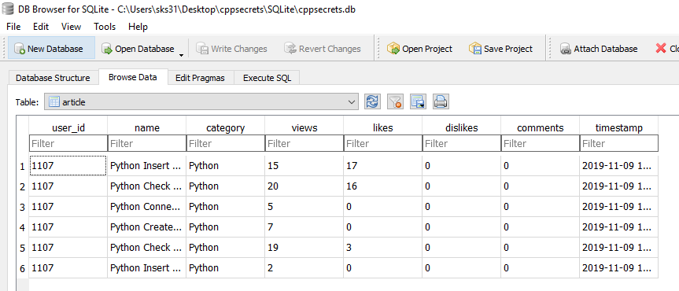

FIG 4.4.5

**4.5 ANACONDA**

Anaconda is a free and open source distribution of the Python and R programming languages for scientific computing (data science, machine learning applications, large-scale data processing ,predictive analysis etc.), that aims to simplify package management and deployment. The distribution includes data-science packages suitable for Windows, Linux, and macOS. It is developed and maintained by Anaconda, Inc., which was founded by Peter Wang and Travis Oliphant in 2012.



FIG 4.5.1

**4.5.1 ANACONDA NAVIGATOR**

Anaconda Navigator is a desktop graphical user interface (GUI) included in Anaconda® distribution that allows you to launch applications and easily manage conda packages, environments, and channels without using command-line commands. Navigator can search for packages on Anaconda.org or in a local Anaconda Repository. It is available for Windows, macOS, and Linux.

**4.5.2 JUPYTER NOTEBOOK**

The Jupyter Notebook is an open-source web application that allows you to create and share documents that contain live code, equations, visualizations and narrative text. Uses include: data cleaning and transformation, numerical simulation, statistical modeling, data visualization, machine learning, and much more.

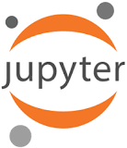

FIG 4.5.2

**4.5.3 SEABORN**

Seaborn is a library that uses Matplotlib underneath to plot graphs. It will be used to visualize random distributions.

* Import matplotlib.pyplot as plt

import seaborn as sns

sns.distplot([0, 1, 2, 3, 4, 5])

plt.show ()

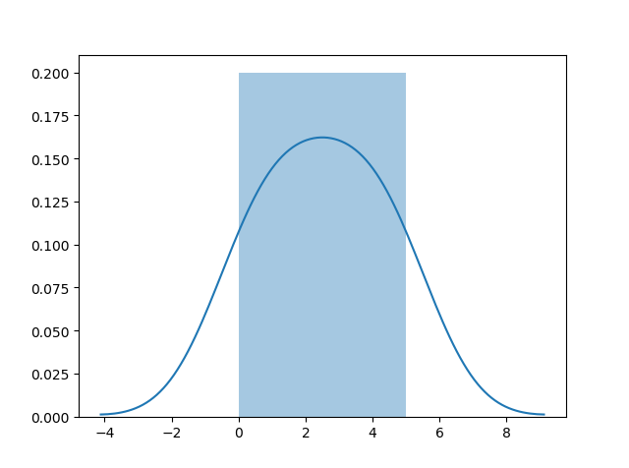

FIG 4.5.3 OUTPUT

**5. CASE STUDY ON POWER CONSUMPTION OF GERMANY**

**5.1 OBJECTIVES**

* Columns with year, month & weekday name
* Graph for Consumption
* Consumption, Solar, Wind using subplots
* Combined graph for consumption in 2016 & 2017
* Consumption graph in July 2016
* Consumption graph in a week in 2016
* 7.Customise the axes to plot weekly granularity to plot a graph
* 8.Show seasonality with Bar graphs
* 9.Plot a graph for monthly resampled data
* 10.Plot a consumption bar graph for years
* 11. Using Additive Model and Seasonal Decompose plot a graph for consumption

**5.2 PROJECT INFORMATION**

Power Consumption analysis of electricity consumed in Berlin and rest of Germany is produced in chronological order. The data collected is based completely from German Electricity Board after sharp scrutiny. Data collection of at least 10 years from 2006-16. This also helps the Govt. to move through Sustainable Development and to know the parameters and yearly developments on Usage and Consumption.

**6. CASE STUDY IN JUPYTER NOTEBOOK-RESULTS & OBSERVATIONS**

**IMPORTING LIBRARIES IN CSV FORMAT**

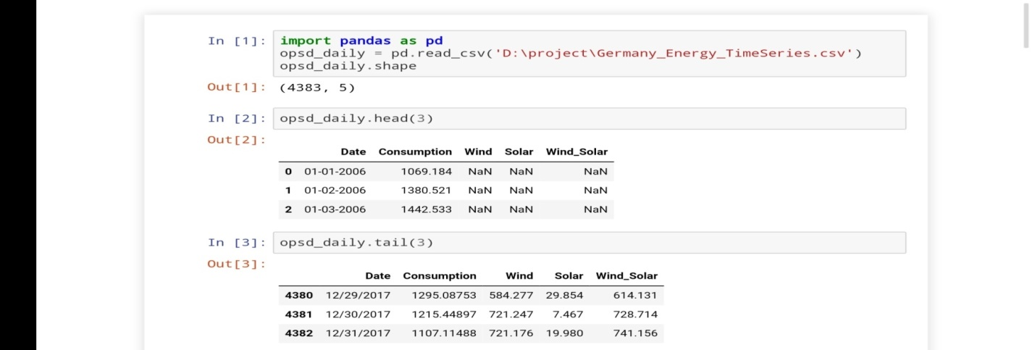

FIG 6.1

**COLUMNS WITH YEAR, MONTH AND WEEKDAY**

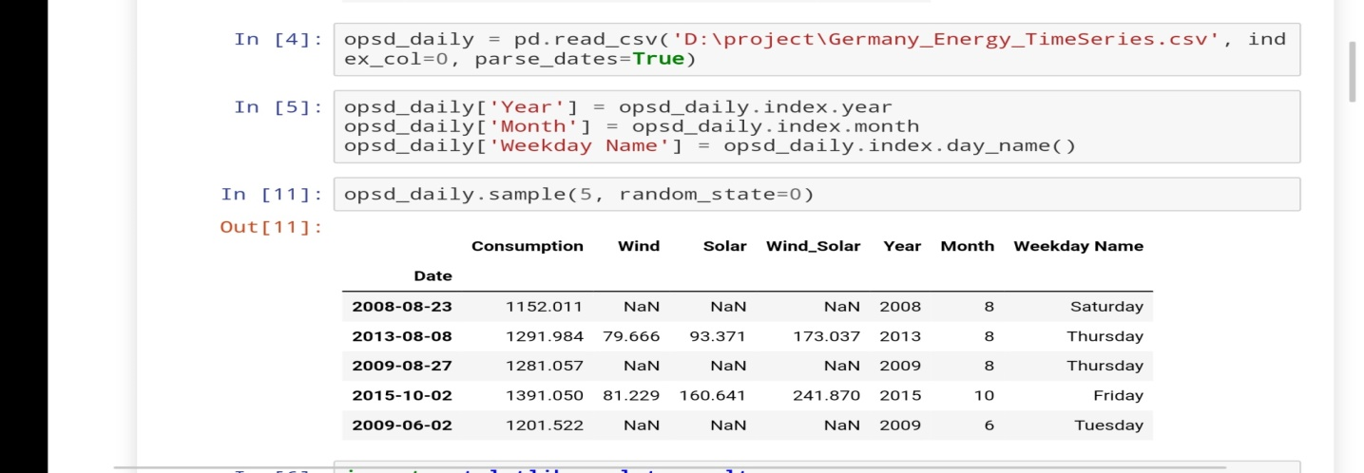

FIG 6.2

**GRAPH FOR CONSUMPTION**

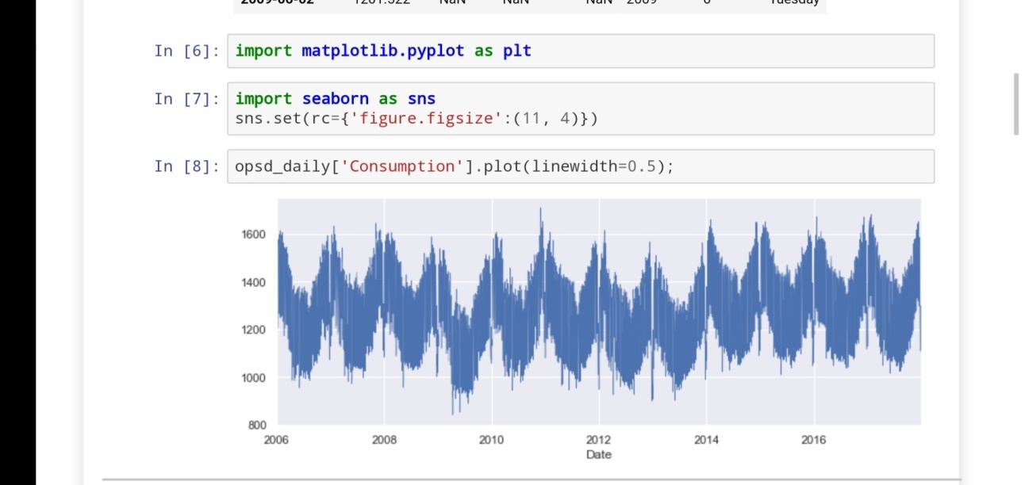

FIG 6.3

**CONSUMPUPTION JULY 2016**

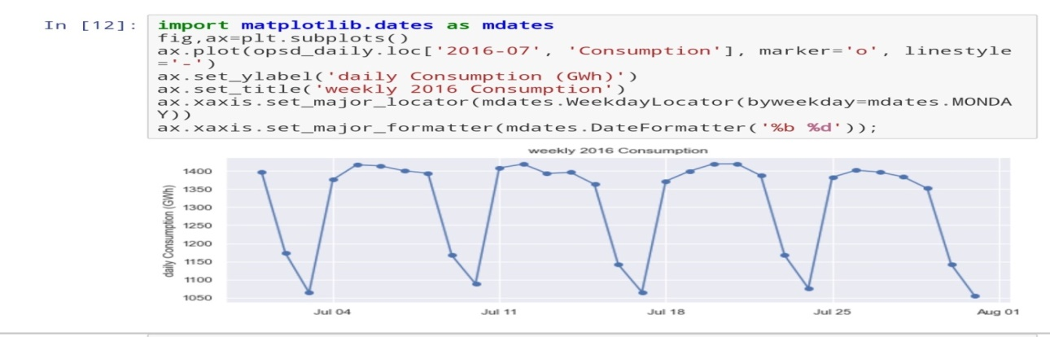

FIG 6.4

**CONSUMPTION OF SOLAR, WIND WITH SUBPLOTS**

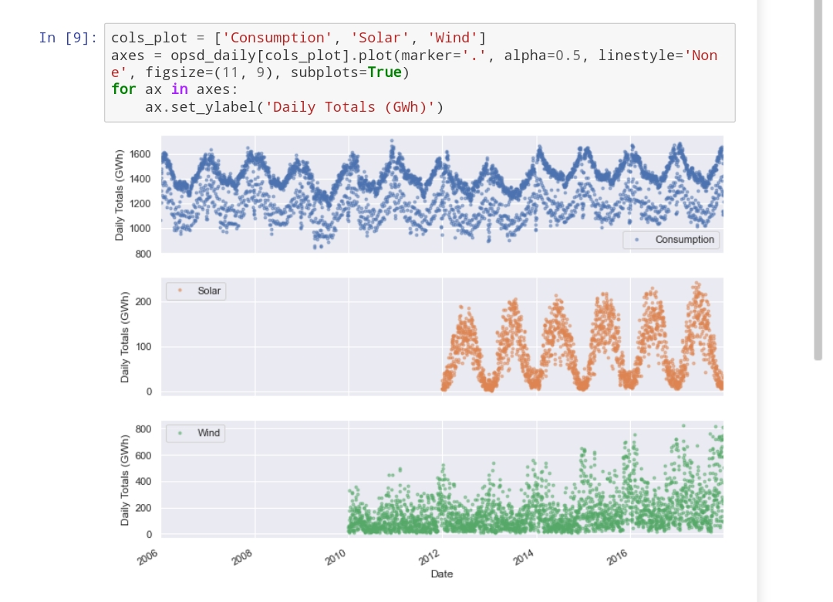

FIG 6.5

**CONSUMPTION IN WEEK OF 2016**

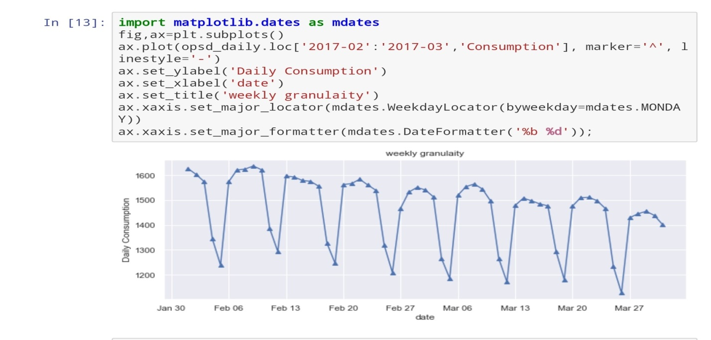

FIG 6.6

**COMBINED CONSUMPTION 2016-17**

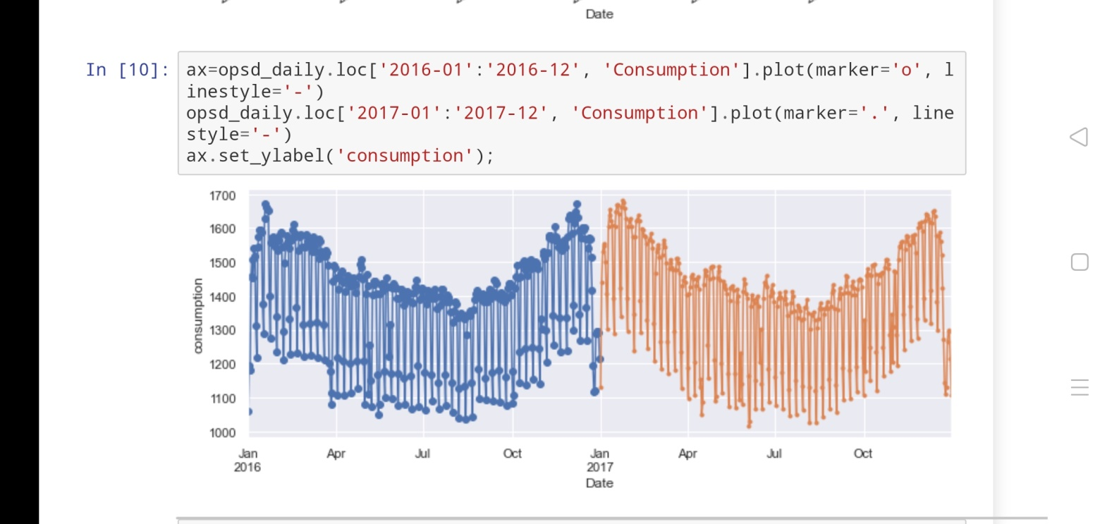

FIG 6.7

**SEASONALITY WITH BAR GRAPH**

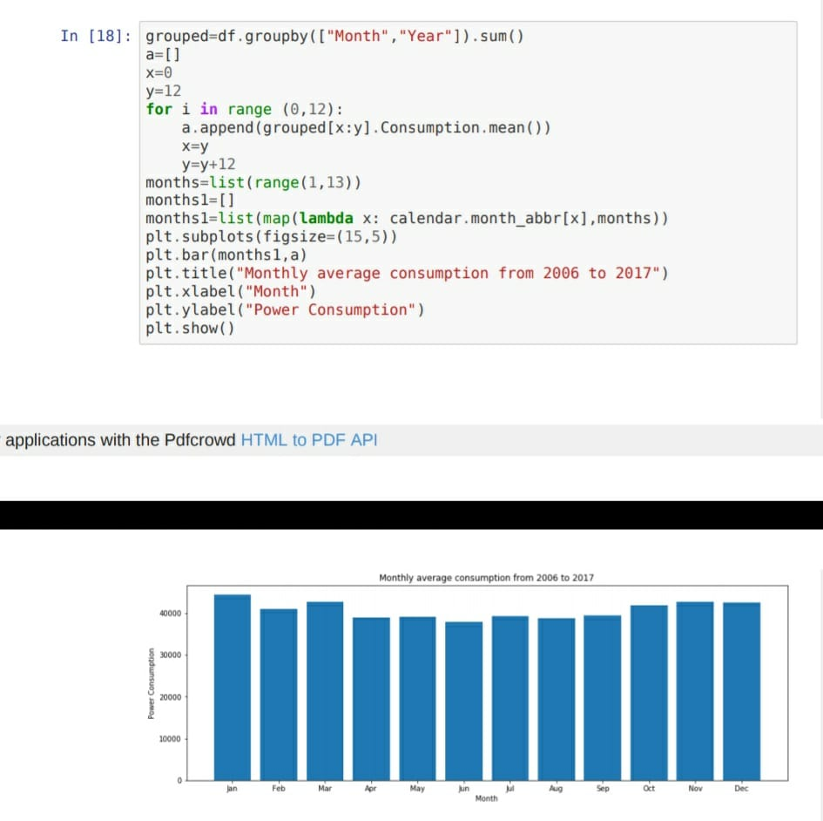

FIG 6.8

**CONSUMPION BAR PLOTS OVER YEARS**

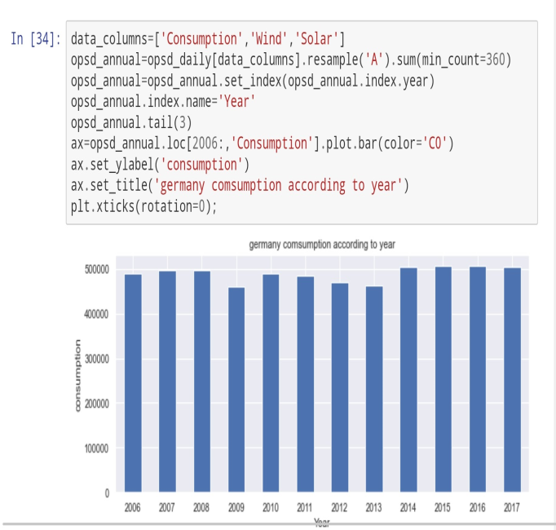

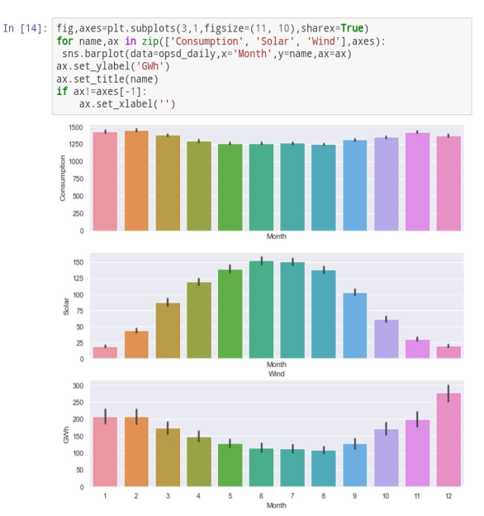

FIG 6.9

**ADDITIVE AND SEASONAL DECOMPOSE PLOT**

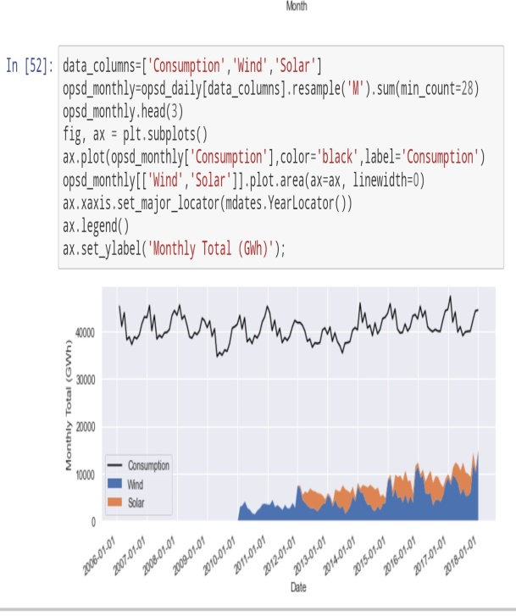

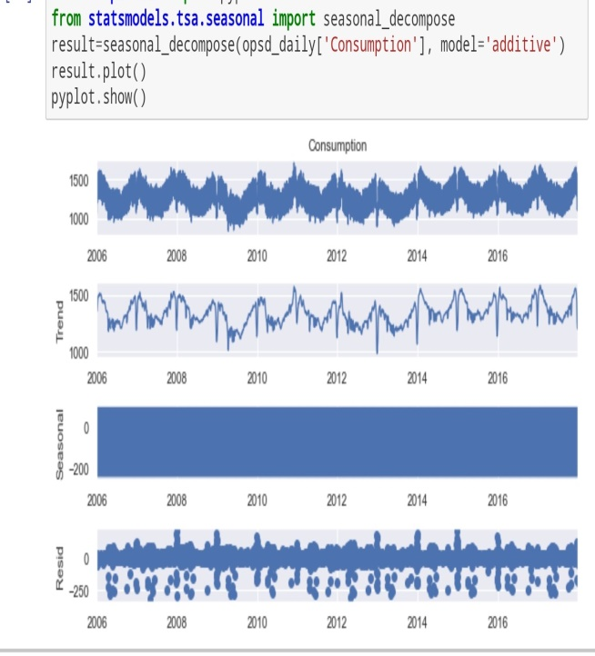

FIG 6.10

**7. PROJECT CERTIFICATE**

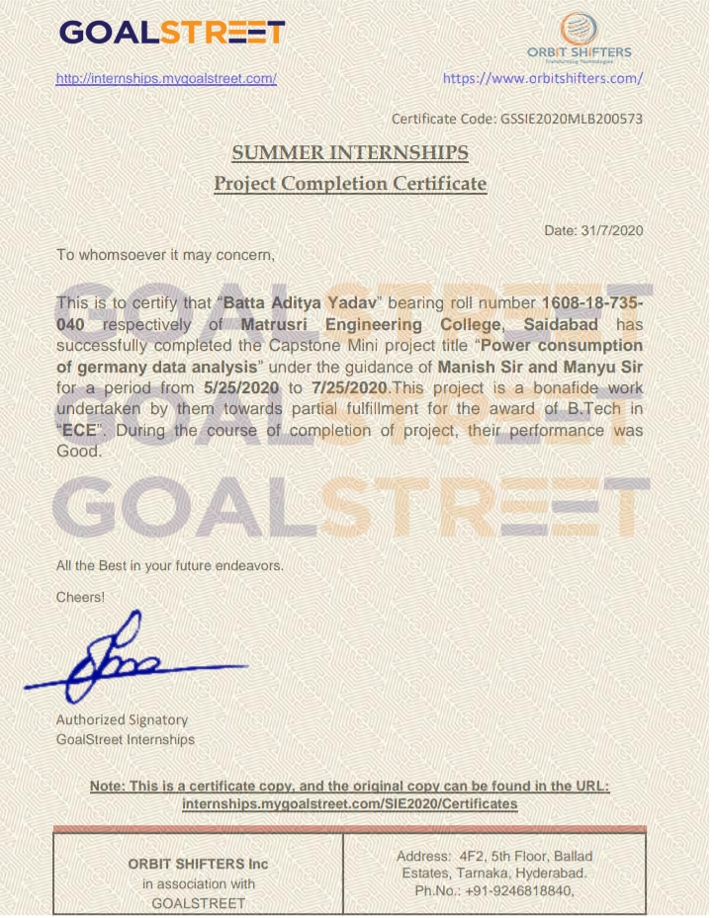

**8. SKILLS ACQUIRED**

**8.1. TECHNICAL SKILLS**

* Python was learnt.
* Libraries in python were learnt.
* Numpy , panda’s basics were known.
* Web development, bootstrap ,CCS basics were also observed.
* Programming exposure was also a better skill after a long gap.
* Documentation and PPT formats were learnt.

**8.2. PROFESSIONAL SKILLS**

* Team work and management.
* Time management
* Communication and Proficiency in language

**9. CHALLENGES EXPERIENCED**

* During lockdown the biggest challenge was online learning and was bit difficult for us to cope up with teaching.
* Internet issues were frequently the biggest hurdle in learning.
* In 4 week of span it was also a big lesson to learn a language in given period of time.
* A kind of psychological and mental pressure ruined our minds alongside online classes with intern classes.
* Technological problems like eye strain, headache over continuous watching of smart devices was common as this was new to us.
* Some kind of connection between teacher and student was lost during online intern.
* Most frequent problem that arouse was low battery run out.
* Amid the lockdown , financial crisis is also a point to remember.
* Overall the equations of challenges faced in all directions were co centred and balanced with itself.

**10. CONCLUSION**

A lot was learnt from the basic features to complex data science of Python. Analytical thinking ability and forum of problem solving with logical analysis was reliably formulated and learnt with intern studies. Being our first intern it was a bit exciting as well as formulative for future studies and jobs. Python has an extensive and comprehensive collection of freely available packages covering a variety of topics. Scientific Python libraries such as NumPy, SciPy, and pandas provide efficient implementation of numerical operations and tasks common in science and engineering. These libraries provide a strong base from which more advanced scientific software can be built without needing to worry about low-level algorithms. Additionally, many domain specific packages exist which address the scientific needs of the meteorological community. In growing Globalization and fast moving World, each and every nation wants to excel high and make its best in terms of education, health and administration. To obtain such a feat one must carve a niche of their own and must focus on well-developed and highly efficient infrastructure. Infrastructure and its developmental updates with synchronous technology and innovationProductivity of language is widely appreciated in all walks of social networking sites. Updated versions of Python with new programming languages are developed using friendly user interface through internships .It was a very touching experience and would like to move forward by imbibing and inculcating new skills of technology and better way of innovation learning. Overall courtesy , modesty , generosity of mentors and staff must be appreciated that they had paved a way for career of many students to find a shoe that could suit them and fit their foot in this competition and collaboration world.

**11. WEEKLY INTERNSHIP PROGRAMMES**

|  |  |  |  |
| --- | --- | --- | --- |
| 1st Week | Date | Day | Topic |
| 11 May | MONDAY | Hmtl5 , Css3 |
| 12May | TUESDAY | Java script , Juery |
| 13 May | WEDNESDAY | Python introduction |
| 14 May | THURSAY | Data types file I/O |
| 15May | FRIDAY | Python operators |
| 2nd Week | Date | Day | Topic |
| 18 May | MONDAY | Control statements |
| 19 May | TUESDAY | Function generators |
| 20 May | WEDNESDAY | Oops introduction |
| 21hMay | THURSAY | Classes and objects |
| 22 May | FRIDAY | Inheritance |
| 3rd Week | Date | Day | Topic |
| 25 May | MONDAY | File handling |
| 26 May | TUESDAY | Numpy introduction |
| 27 May | WEDNESDAY | Numpy operators |
| 28 May | THURSAY | Pandas introduction |
| 29May | FRIDAY | Reading data using pandas |

|  |  |  |  |
| --- | --- | --- | --- |
| 4th Week | Date | Day | Topic |
| 1 June | MONDAY | Matplotlib,pyplot |
| 2 June | TUESDAY | Data visualisation |
| 3 June | WEDNESDAY | Sqlite,msql |
| 4 June | THURSAY | Case studies |
| 5 June- 25 June | FRIDAY | Project |

**12. BIBLIOGRAPHY**

www.w3schools.com › python_intro

Introduction to Python - W3Schools

www.tutorialspoint.com › python

Python Tutorial – Tutorialspoint

Python For Beginners. Python.org. (2021). Retrieved 3 February 2021, from <https://www.python.org/about/gettingstarted/>.

Study Resources | Python Institute. Pythoninstitute.org. (2021). Retrieved 3 February 2021, from https://pythoninstitute.org/free-python-courses/?gclid=CjwKCAiAsOmABhAwEiwAEBR0Zi2O0by7kvKBXnqVhYK87Xde6IWWbWC1v-XbZMDwJeKEkPQPWBxDuhoCHvAQAvD_BwE.